Evolving Multi-Agent Interrogators for Large Language Models

1. Overview and Motivation
This project investigates how to evolve a collection of cooperating and supervising agents that can reliably extract high-quality, relevant information from large language models (LLMs). The core idea is to define agents through personas—concretely, through prompt-prefixed behavioral specifications—and then evaluate and iteratively improve those personas using structured multi-agent interactions.
The immediate goal is not to create a single optimal interrogator but rather to build a framework in which interrogators can be iteratively refined, evaluated, and compared in a principled way. The broader goal is a system that can continue improving through recursive feedback, and that remains adaptable as LLM capabilities and interfaces change.

2. High-Level Architecture and Roles
The system organizes several distinct agent types into a hierarchy that supervises itself.
- The Actor is the primary target of optimization; it plays the role of the interrogator attempting to extract relevant information from a target model.
- The Grader evaluates the informational quality of what the Actor extracts: relevance, completeness, task progress.
- The Director evaluates how well the Actor performs the role itself: strategy, adherence to persona, quality of interaction with the environment.
- The Screenwriter defines the problem, objectives, constraints, and information-extraction scenario, initially conceived as a human role, but possibly an LLM agent, possibly subject to optimization in the future.
- The Theater is the model being interrogated; it is not subject to optimization.
Above these sit the meta-roles.
- The Producer supervises Screenwriter (if an agent), Grader, Director, and Actor, judging how well the evaluators perform.
- The Critic evaluates the Producer, forming the highest layer of recursion in the system.
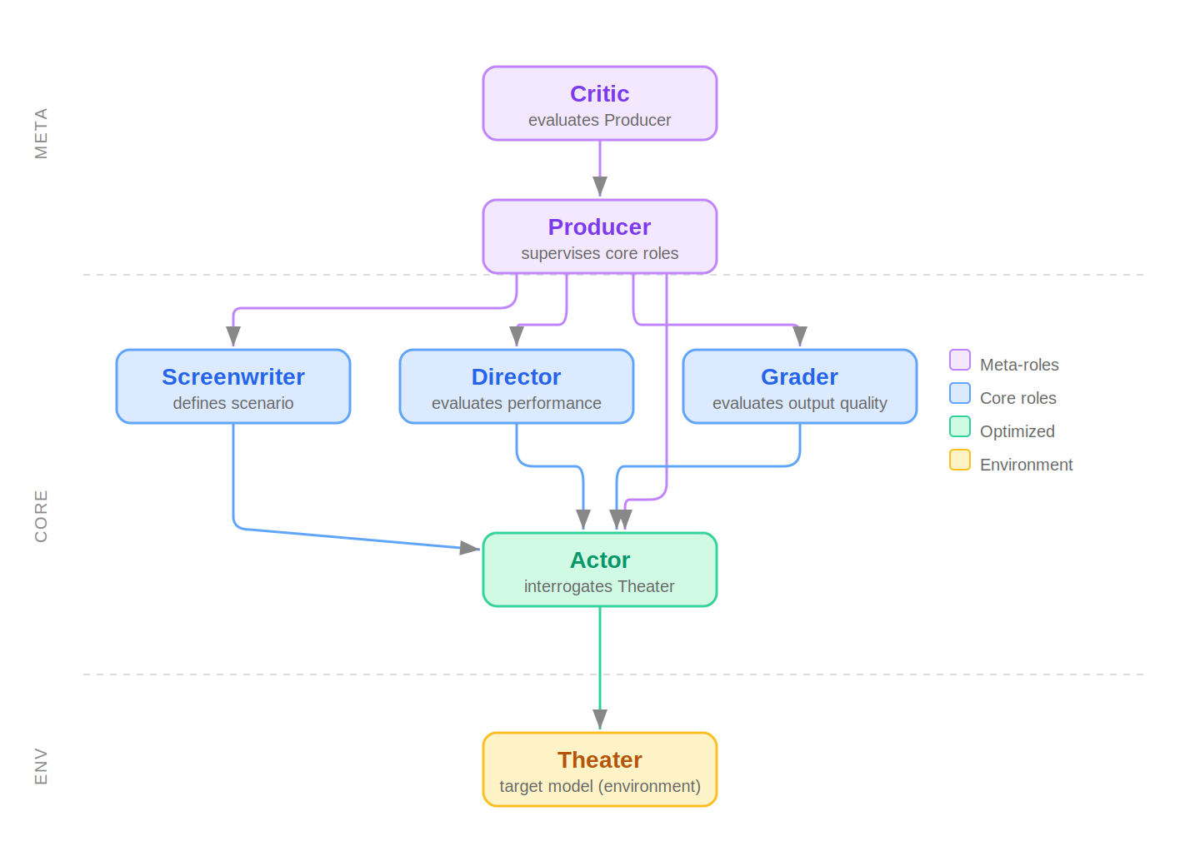
The hierarchy is flexible; different topologies may ultimately perform better depending on empirical results.

3. Sampling
A sample consists of the entire multi-agent conversation: the Screenwriter’s scenario, all of the Actor’s turns with the Theater, all evaluations by the Grader and Director, the Producer’s assessment of those evaluations, the Critic’s assessment of the Producer, plus all personas and configurations.
The sampling approach is meant to act as a Monte Carlo–style exploration mechanism: many degrees of freedom can be explored without resorting to search or enumeration by treating them as sampled random variables. Examples include persona variations, settings for parsing and rating, choice of evaluation models (which are not necessarily the Theater), temperature settings, or selection of the Theater model. Essentially, any property of the system can be made into a random variable in order to expand optimization to include that dimension.
To enforce sample independence, limit statefulness, and skip by design all evaluation that will not be assessed and rated, sampling may be framed functionally. For the above topology, sampling constitutes evaluating the Critic’s assessment of the Producer given the personas and configurations; since this is the last step, evaluation hangs while all other activity is recursively generated as attempts are made to fetch the activities of lower levels of the hierarchy. In practice, to facilitate debugging long-running processes, a stack-based procedural machine that simulates such functional sampling may be more practical.
To make these complex interactions inspectable, samples are structured as email-like threads for each agent. Whenever agents communicate or respond to each other, the resulting “conversation” appears as a message in that agent’s inbox. Multi-agent interactions that might otherwise be a confusing tangle become familiar, and debugging is simplified since long and branching threads can be read the same way one reads an email chain.
Hierarchical Probability of a Sample Configuration
If a sample’s configuration arises from a hierarchy of random choices c₁, c₂, …, cₖ, each conditioned on the preceding ones, then the probability of drawing a specific configuration is:
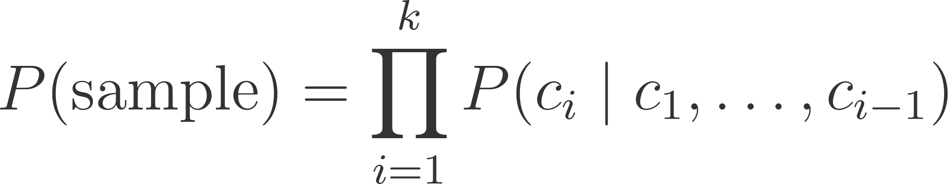
Even parameters of processes that involve variable numbers of steps—such as stochastic parse-retry loops—fit naturally into this formulation because their downstream contribution to scoring remains well-defined. This template can be adapted as needed when formalizing the sampling process.

4. Optimization Strategy
An initial strategy, a modified beam search, maintains a population (“beam”) of samples of a constant size, e.g. 1000. For each iteration, each existing sample is used to propose at least one variant. Additional variants may be generated stochastically based on a sample’s rating. All candidates—new and existing—form a pool, and the lowest-scoring samples are dropped until the population is back to the beam size.
This procedure maintains diversity and avoids early convergence while still allowing strong performers to propagate. Although this resembles beam search, it is not constrained by a fixed search depth or a strongly tree-structured process; rather, it leverages the rich variability of the sample format. More sophisticated sampling or evolutionary strategies may later be substituted. The current design is intended as a practical and interpretable starting point.

5. Implementing Changes to Personas and Behavior
Changes to personas or agent behavior are generated by the supervising agents and then incorporated into new variants. A baseline mechanism is block-level search-and-replace editing of the persona definitions or role descriptions. This method is simple, transparent, and compatible with nearly all LLMs, including those with limited interfaces.
Persona modification occurs primarily through prompt engineering: adding, removing, or altering text in the persona’s prompt prefix. This captures the idea of an “agent” in the way originally suggested for the project and remains the most concrete and universally applicable method of specifying behavior.
While block edits are simple, they provide a sufficiently rich space for experimentation. The method by which changes are implemented is flexible—search-and-replace on blocks of text is a practical baseline, but any technique that can modify structured text data would work, including methods where a model is asked to produce a structured diff or a set of targeted edits. This flexibility extends naturally to more sophisticated transformation methods as the system matures.

6. Execution Robustness and Structured Outputs
Since some stages of the evaluation cycle rely on machine-processable outputs, the system must enforce formatting to enable parsing, and provide a framework for retries. In many cases, models need to be asked to respond in a structured way—for example, producing a JSON object with a numeric rating field—so that downstream logic can parse out specific values and perform computations. The rating system and optimization pipeline require quantitative comparison of samples, and that comparison must be automated.
Structured response formats (e.g., JSON fragments or fixed-field templates) make it possible to detect malformed outputs, and request a retry until a parseable form is produced.

Example Structured Output Request
Please respond with a JSON object:
{
"rating": <integer 1-10>,
"justification": "<one-sentence explanation>"
}
If the format is incorrect, I will ask you to retry.

7. The Rating System and Iterative Depth Encoding
The basic unit of evaluation is a rating on a 1–10 scale. Each given rating is mapped into the unit interval via rᵢ = (given_ratingᵢ − 1) / 10, so that a rating of 1 maps to 0.0, and a rating of 10 maps to 0.9. This mapping is chosen to enable use as pseudo-probabilities in computations.
Ratings from evaluators tend to saturate at the high end of the scale: models frequently choose 9 or 10 when asked to judge quality. When many evaluations cluster at the maximum value, rating resolution collapses—the landscape of answer ratings becomes stepped and low-fidelity.
To recover resolution, the system asks for conditional ratings. If too many models give a rating of 9 or 10, those providing a 10 are asked to rate the same item on a new scale: "Please say why you rated 10, and among answers you would rate 10, rate this from 1–10 and explain." If it again gives 10, the question repeats: "Among things you would rate 10 within that group, again rate 1–10 and explain." This recursion continues until the model produces a non-10 or until a maximum reflection depth is reached. The exact phrasing is iterated to remain intelligible to the model at each level of nesting—for example, clarifying the scope of comparison at each depth so the model understands it is being asked to discriminate within an increasingly narrow subset.
Depth-to-Decimal Mapping
Let  be the rating given by the LLM at iteration 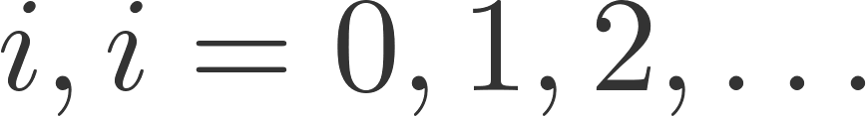
Let 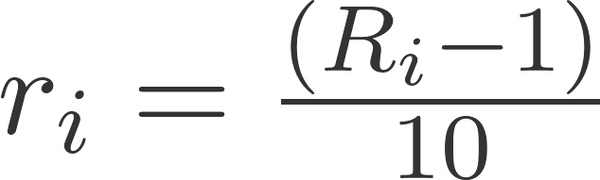 if a rating was given at depth , and 0 otherwise.
The composite rating  is the power series
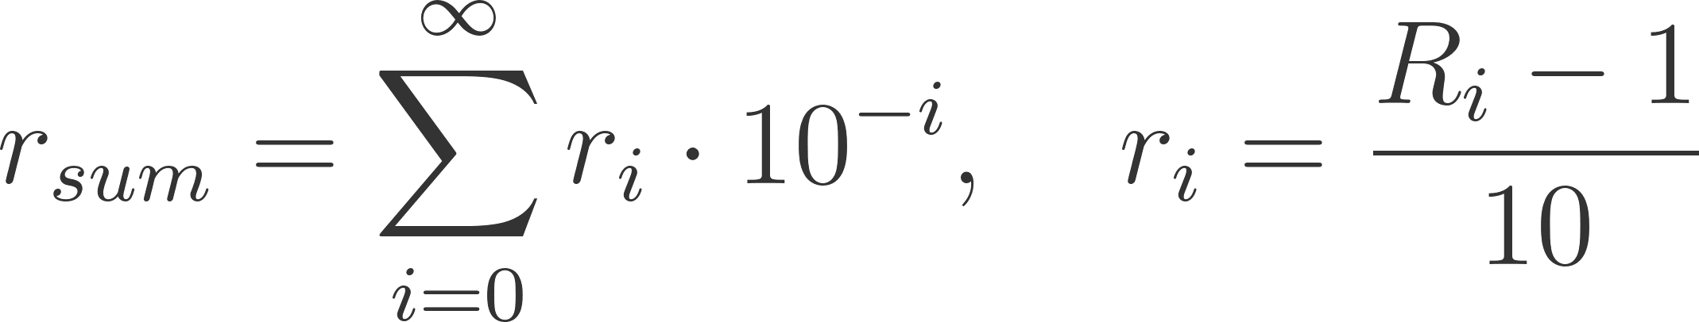​
Suppose the sequence of given ratings  to  is 10, 10, 10, 4.
Then,  through  are 0.9,  is 0.3,  is 0 for , and:

Stochastic chains of retries can be rated by meta-level agents and included without breaking the scoring system by treating them as iterated conditional probabilities.
Results may be treated as unnormalized probabilities, that is, probabilities up to proportionality, if that is all that is required for sampling, as is often the case when using Monte Carlo methods. If needed, distributions may be made well-defined for sampling across a population with standard techniques, like proportional normalization or softmax.
This process provides high-resolution quantitative evaluations and supports nuanced comparisons among samples that would otherwise appear tied.

8. Model Flexibility

Builder Pattern, API Variation, and Conditioning Methods
LLM APIs differ widely. Some expose extensive configuration: temperature, top-p, reasoning effort, tools, multiple instruction channels, multimodal inputs. Others—particularly local models such as those served through Ollama or similar lightweight engines—provide only a minimal interface. To work across all of these, a flexible mechanism is required.
A builder pattern provides this flexibility. The builder pattern is a software design pattern in which a separate “builder” object accumulates configuration choices step by step before producing a final, immutable request object. In one common style of builder, fluent style, each configuration method returns the builder itself, allowing calls to be chained. The result is a consistent interface that starts from a standard baseline configuration, applies persona-dependent modifications, applies evaluator- or Director-recommended changes, and finally compiles a request appropriate for the target model.
The builder ensures that unsupported fields are automatically stripped or ignored, supported fields are encoded correctly, persona prefixes are injected into whichever input slot the model uses (system prompt, message prefix, etc.), and advanced models can consume richer configuration without disturbing weaker ones.

Builder Pattern Examples
Fluent builder → default API query:
query_builder = (QueryBuilder("ollama/llama3")
.with_persona(screenwriter.persona_str)
.with_scenario(scenario_prompt)
).build()

query = query_builder.send(message)

# Resulting JSON:
{
"model": "llama3",
"temperature": 0.7, # a default
"messages": [
{"role": "system", "content": "<persona text>"},
{"role": "user", "content": "<scenario prompt> The user says: <message>"}
]
}

Modified builder with additional fields:
query_builder = (QueryBuilder("anthropic/claude-sonnet")
.with_persona(actor.persona_str)
.temperature(0.3)
.max_tokens(8000)
.reasoning_effort(MEDIUM_EFFORT)
.with_tool_declarations(tools)
.with_scenario(scenario_prompt)
).build()

query = query_builder.send(message)

# Resulting JSON:
{
"model": "claude-sonnet",
"temperature": 0.3,
"max_tokens": 8000,
"reasoning_effort": "medium", # formatted for anthropic
"tools": [ ... ],
"messages": [
{"role": "system", "content": "<persona text>"},
{"role": "user", "content": "<scenario prompt> The user says: <message>"}
]
}

When the target is a minimal API (e.g., Ollama), fields such as “tools” are silently dropped by the builder. When the target is a richer API, they are included. The builder abstracts this, so the rest of the system does not need to know which fields a given model supports.
Prompt-prefix persona engineering continues to serve as the primary way agents are shaped, since it is the most widely supported method. However, modern models increasingly support capabilities beyond what is expressible through prompt prefixes alone. Some models accept internal conditioning states, specialized instruction channels, domain-biasing fields, or explicit toggles for tool use. Tool use in particular has transformed LLM capabilities in the period of a few months prior to time of writing; while making network requests or internet searches at scale within every sample may not be practical, allowing tool access sparingly—or at least building the system so it could support tool use—would help keep the generated personas relevant to what modern hybrid, multimodal, tool-use-fine-tuned models are actually producing. Without this consideration, there is a risk that the system’s outputs become obsolete before the project is complete.

9. Open Questions and Future Paths
The question of whether models, those evaluated locally in particular, can be shaped in more sophisticated ways than prompt engineering is open. For example, comparatively cheap manipulations like activation pinning and weight subsetting, applied before a query is submitted at all, may outperform filling up context windows with persona text. The poster child of direct activation engineering is the May 2024 “Golden Gate Bridge Claude” demonstration; the simple pinning method used there has since developed into a much more powerful and general suite of tools. A few local inference engines now expose richer configuration than the minimal defaults, and the landscape is evolving quickly. The builder pattern naturally accommodates such extensions: modifications to local models are staged before querying, advanced remote models receive structurally richer requests, and simpler models fall back to personas defined primarily in text. The high number of expected inference steps for a full optimization, easily running into the millions, will constrain which features can be used practically at any given moment.
The role topology described above is a starting point, and a natural question is what topology works best. Different supervisory structures may yield different stability, interpretability, or optimization strength. Role-recursion depth—Critic evaluating Producer evaluating Grader, Director, Screenwriter, and so on—may be an especially sensitive parameter.
A separate design question concerns the sample space dimensionality: which properties should be randomized within samples, and which should remain fixed? Too few dimensions may cause the optimizer to fail to exploit rare, high-performing combinations of parameters; too many may make optimization noisy. The right balance will likely depend on the specific roles and properties being optimized and will need to be determined empirically.
Finally, there is the question of generalization across models. The Theater model, previously framed as static, could be assigned randomly before generating each sample, or be drawn from a distribution multiple times throughout generation of a single sample. This would force evolved personas and configurations to avoid overfitting to the quirks of a particular LLM, improving robustness to vendor changes and giving the system a better chance of remaining relevant long enough to reach publication—a nontrivial concern in a field that moves as fast as this one. However, generalization comes at the cost of constraining expressivity to the lowest common denominator if little configuration is in common, making most dimensions of optimization irrelevant for most models. A requirement that all agents work across all models might make the entire space of solutions too weak to be relevant to models in production. Whether to prioritize generality, expressivity, or some hybrid remains to be determined.

